**EXPERIMENT- 6**

**Implement Aggregate Functions, Group by & Having Clauses, Nested, Correlated Nested,**

**Views, Indices and DCL Commands on**

**Case Study 1 & 4 (TRANSPORT DEPARTMENT) & (KL University ERP)**

PRE-LAB :

1. Discuss about GRANT, REVOKE and SYNONYM  
2. Give the differences between AVERAGE and ROUND commands?  
3. What is the use of VIEW statement in SQL?  
4. Discuss about any 5 aggregate functions.

5.What do you mean by a nested query in SQL?  
6. What are the pattern matching operators that can be used in mySQL?  
7.Write a SQL Query to display the Current Date?  
8. Discuss about any 5 Character Manipulation functions?  
9. Display the structure of the table?  
10.What is meant by aliasing in SQL?

IN-LAB:

Use the tables and data in Experiment – 5**,**In-Lab section and work on the following queries

**Case Study 1 - Transport Department**

1. Display the list of customers available in a branch.
2. Create a mysql query to know the older of all the customers
3. Write mysql query to calculate the total amount generated by giving contract permission for amount per seat
4. Create a query to display all the type of vehicles present
5. Write mysql query todisplay all the cities present in a given state.
6. Display the number of vehicles of customers who are not having photo identity.
7. Write mysql statement to search for vehicle type which is having the vehicle id as the smallest number.
8. Create a mysql query to know the branch name and phone number of a customer who is having license period of 2 years .
9. Display the vehicle details for which maximum amount is paid per seat for contractpermission.
10. Write Co-related nested subquery to know the customer name , phone number, city whose branch name is ‘Madhapur’
11. Create a view “Present_Customer” with customer name , phone number, state and city of customer and display the view.
12. Write mysql query to show indexes on customer table.
13. Create a query to display the count of dealers from “Andhra Pradesh”
14. Display the number of cities in each state
15. Drop the view “Present_Customer”

Use the tables and data in Experiment – 5, In-Lab section and work on the following queries

**Case Study 4 – KL University ERP**

1. Write a query to display the names, annual salary of all the faculty based on decreasing order of their annual salary.
2. Write a query to get the third highest salary of a faculty
3. Write a query to display the total value of books available in the Library using aggregate function.
4. Write a query to display the Regd.no, name and the Average CGPA of each student for the entire 1st year using aggregate and group by clause
5. Write a query to display the number of courses available in 2nd year branch wise, that contains atleast two courses per branch using Aggregate Functions with GroupBy & Having Clauses
6. Write a query to display the students and the book name issued to him/her in the month of May.
7. Write an SQL query to display the names of students, their branch, the courses they have registered, and the faculty teaching the course.
8. Write a query to display the names of students who have joined the hostel using a Nested Query
9. Write a query to display the student name who has registered for DBMS Course using Nested Query
10. Write a query to display the titles of the three most expensive books available in the Library.
11. Write a query to create a View named Student_Details with the following data: Registration No., Name, Mobile No., Branch, Registered Course Name, Faculty Name
12. Write a query to find the number of students who have registered for at least one using the view named Student_Details which already has the following columns: Registration No., Name, Mobile No., Branch, Registered Course Name, Faculty Name.
13. Write a query to create a Unique Index value for the Students

POST-LAB:

Table **– Worker**

|  |  |  |  |  |  |
| --- | --- | --- | --- | --- | --- |
| WORKER_ID | FIRST_NAME | LAST_NAME | SALARY | JOINING_DATE | DEPARTMENT |
| 001 | Monika | Arora | 100000 | 2014-02-20 09:00:00 | HR |
| 002 | Niharika | Verma | 80000 | 2014-06-11 09:00:00 | Admin |
| 003 | Vishal | Singhal | 300000 | 2014-02-20 09:00:00 | HR |
| 004 | Amitabh | Singh | 500000 | 2014-02-20 09:00:00 | Admin |
| 005 | Vivek | Bhati | 500000 | 2014-06-11 09:00:00 | Admin |
| 006 | Vipul | Diwan | 200000 | 2014-06-11 09:00:00 | Account |
| 007 | Satish | Kumar | 75000 | 2014-01-20 09:00:00 | Account |
| 008 | Geetika | Chauhan | 90000 | 2014-04-11 09:00:00 | Admin |

Table – **Bonus**

|  |  |  |
| --- | --- | --- |
| WORKER_REF_ID | BONUS_DATE | BONUS_AMOUNT |
| 1 | 2016-02-20 00:00:00 | 5000 |
| 2 | 2016-06-11 00:00:00 | 3000 |
| 3 | 2016-02-20 00:00:00 | 4000 |
| 1 | 2016-02-20 00:00:00 | 4500 |
| 2 | 2016-06-11 00:00:00 | 3500 |

Table – **Title**

|  |  |  |
| --- | --- | --- |
| WORKER_REF_ID | WORKER_TITLE | AFFECTED_FROM |
| 1 | Manager | 2016-02-20 00:00:00 |
| 2 | Executive | 2016-06-11 00:00:00 |
| 8 | Executive | 2016-06-11 00:00:00 |
| 5 | Manager | 2016-06-11 00:00:00 |
| 4 | Asst. Manager | 2016-06-11 00:00:00 |
| 7 | Executive | 2016-06-11 00:00:00 |
| 6 | Lead | 2016-06-11 00:00:00 |
| 3 | Lead | 2016-06-11 00:00:00 |

#### Create a SQL query to display employeesdetailswhose salary is greater than 30000 and less than 50000

#### Display the no. of employees in each department

#### Display the count of employees with same designationin an organization

1. Problem:

Sharon was tasked with calculating the average monthly salaries for all employees in the **EMPLOYEES** table, but did not realize her keyboard's  key was broken until after completing the calculation. She wants your help finding the difference between her miscalculation (using salaries with any zeroes removed), and the actual average salary.Write a query calculating the amount of error (i.e.:  average monthly salaries), and round it up to the next integer.

**Input Format**

The **EMPLOYEES** table is described as follows:

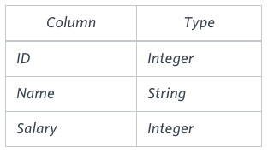

**Note:** Salary is measured in dollars per month and its value is .

**Sample Input**

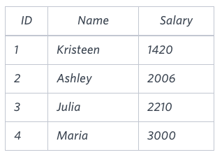

**Sample Output**

2061

**Explanation**

The table below shows the salaries without zeroes as they were entered by Samantha:

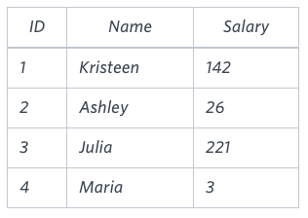

Sharon computes an average salary of 98.00. The actual average salary is 2195.00 . The resulting error between the two calculations is 2195.00-98.00=2061.00  which, when rounded to the next integer, is 2061 .